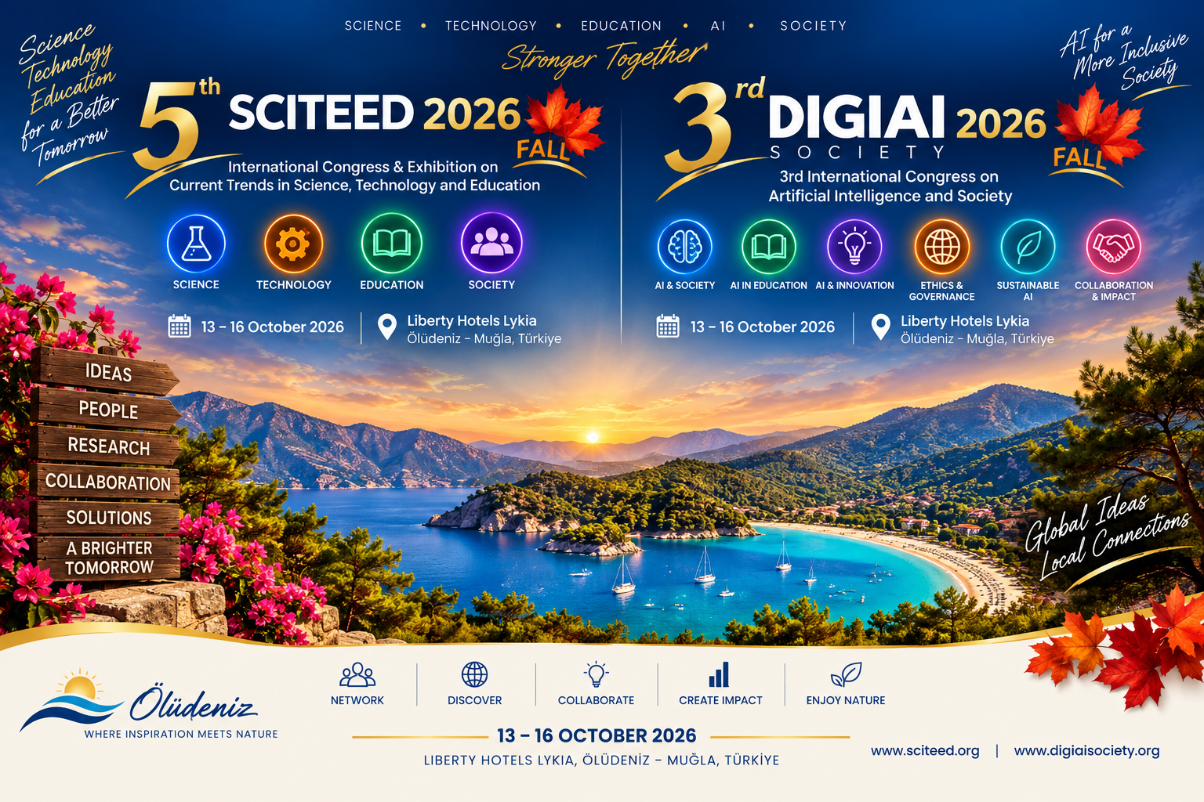

TENTATIVE PROGRAM

DIGIAI SOCIETY 2026 FALL

SCITEED 2026 FALL


Scan the QR Code for Official Websites

DIGIAI SOCIETY 2026 FALL
3rd International Congress on Digitalization, Artificial Intelligence and Society
October 13-16, 2026
Human-Centered Artificial Intelligence & Digital Society

SCITEED 2026
5th International Congress on Science, Technology and Education October 13-16, 2026
Science, Technology & Transformative Education

Liberty Hotels Lykia, Oludeniz MUGLA / TURKEY

TENTATIVE P R O G R A M
SUNDAY, OCTOBER 11, 2026
14:00-16:30 | REGISTRATION FOR EARLY ARRIVALS  (14:00 Check-in)

TENTATIVE P R O G R A M
MONDAY, OCTOBER 12, 2026
14:00-16:30 | REGISTRATION  (14:00 Check-in)
Everyday Tours | SOCIAL PROGRAM  - Saklıkent Jeep Safari  - Paragliding in Oludeniz

TENTATIVE P R O G R A M
TUESDAY, OCTOBER 13, 2026
DIGIAI & SCITEED
EFLATUN
PLENARY SESSION  09:30-10:15 | Chairperson: Ersin Kayahan  Karin Wolf-Ostermann  Universität Bremen, Germany  “ID xxx A Readiness assessment for AI in nursing care projects (AINCRA)- how to o support planning, execution, and evaluation of AI projects”
PLENARY SESSION  09:30-10:15 | Chairperson: Ersin Kayahan  Jana Škrabánková  University of Ostrava, Czech Republic  “ID 309 Eye-Tracking as a Research and Diagnostic Tool in Science Gifted Education: A Decade of Evidence”
11:00-  11:30 | COFFEE BREAK
PLENARY SESSION  11:30-12:15 | Chairperson: Ersin Kayahan  Shyla Kamalakumari Richard  University of East London, United Kingdom  “ID320 Transforming Nursing Education Through Problem-Based Learning: Preparing Future-Ready Nurses”
12:30-  14:00 | LUNCH
PARALLEL SESSION 14:00-15:30 | DIGIAI  EFLATUN  Chairperson: Faruk Civelek  14:00-14:30  Faruk Civelek  Baden-Württemberg Cooperative State University, Germany  (Invited speaker)  ID139 The UPD Model: Three Search Directions for Identifying AI Potentials in Companies  14:30-15:00  Tuan Pham  Queen Mary University of London, United Kingdom  (Invited Speaker)  ID 140 Tensor-based Similarity Networks for Colorectal Cancer Spatial Patterns  15:00-15:30  xxx  xxx, xxx  (Invited Speaker)  ID xx xxxxx
15:30-  16:00 | COFFEE BREAK
PARALLEL SESSION 16:00-17:30 | SCITEED  EFLATUN  Chairperson: xxxx  16:00-16:30  xxx  xxx, xxx  (Invited Speaker)  ID xx xxxxx  16:30-17:00  xxx  xxx, xxx  (Invited Speaker)  ID xx xxxxx  17:00-17:30  xxx  xxx, xxx  (Invited Speaker)  ID xx xxxxx

TENTATIVE P R O G R A M
WEDNESDAY, OCTOBER 14, 2026
DIGIAI & SCITEED EFLATUN
PLENARY SESSION  09:30-10:15 | Chairperson: Ersin Kayahan  Christina Cooper  Northumbria University, United Kingdom  “ID307 Adolescent health: from individual risk behaviours to wellbeing ecosystems: learning from the paradigm shift”
PLENARY SESSION  10:15-11:00 | Chairperson: Ersin Kayahan  María J. Cantalejo  Public University of Navarre, Spain  “ID325 Education for sustainable transformation: a new model of critical and holistic thinking”
11:00-11:30 | COFFEE BREAK
PLENARY SESSION 11:30-12:15 | Chairperson: Ersin Kayahan  Spencer A. Benson  International Consulting, United States  “IDXX When AI Thinks for Us: Finding the Right Balance Between Assistance and Learning”
12:30-  14:00 | LUNCH

 | PARALLEL SESSIONS 14:00-15:30 |  | SCITEED EFLATUN  Chairperson: Davoud Tavousi | DIGIAI IBNI SINA  Chairperson: Veselina Nedeva (Trakia University, Bulgaria)
 |  |  | 14:00-14:30  Davoud Tavousi  Germany  (Invited speaker)  ID319 Self-identified learning needs in style-bound musical improvisation: a qualitative, category-guided analysis for fostering self-directed action | 14:00-14:30  xxx  xxx  (Invited speaker)  IDxx xx  14:30-15:00  xxx  xx, xx  (Invited speaker)  IDxx xx  15:00-15:30  xxx  xx, xx  (Invited speaker)  IDxx xx
14:30-15:00
xxx
xx, xx
(Invited speaker)
IDxx xx
15:00-15:30
xxx
xx, xx
(Invited speaker)
ID270 From Social Media to Artificial Intelligence: Digital Transformation in Dental Education
 | 15:30-  16:00 |  | COFFEE BREAK
 | PARALLEL SESSIONS 16:00-17:30 |  | SCITEED  EFLATUN  Chairperson: xxxx  16:00-16:30  xxx  xxx, xxx  (Invited Speaker)  ID xx xxxxx  16:30-17:00  xxx  xxx, xxx  (Invited Speaker)  ID xx xxxxx  17:00-17:30  xxx  xxx, xxx  (Invited Speaker)  ID xx xxxxx | DIGIAI IBNI SINA  Chairperson: xxxx  16:00-16:30  xxx  xxx, xxx  (Invited Speaker)  ID xx xxxxx  16:30-17:00  xxx  xxx, xxx  (Invited Speaker)  ID xx xxxxx  17:00-17:30  xxx  xxx, xxx  (Invited Speaker)  ID xx xxxxx
 | POSTER SESSION  17:30-18:30 |  | FOYER (Poster Session Area) Chairperson: Ersin Kayahan POSTER SESSION  DIGIAI & SCITEED
 | 19:30-21:30 |  | SPECIAL DINNER WITH SCITEED & DIGIAI SOCIETY PLENARY - INVITED SPEAKERS  (Authentic Turkish Cuisine)
TENTATIVE P R O G R A M
THURSDAY, OCTOBER 15, 2026
DIGIAI & SCITEED
EFLATUN
PLENARY SESSION  09:30-10:15 |  | Chairperson: Ersin Kayahan  Nikolaus Albrecht  University College of Teacher Education Tyrol, Austria “ID316 Teacher Expertise in the Age of AI: Which Parts of Expert Teaching Can Be Supported—and Which Can Never Be Delegated?”
PLENARY SESSION  10:15-11:00 |  | Chairperson: Ersin Kayahan  Maria Kay  United Kingdom “ID311 The Road to Success in English Language and Literacy Learning”
11:00-  11:30 |  | COFFEE BREAK
PLENARY SESSION  11:30-12:15 |  | Chairperson: Ersin Kayahan  James Purdy  Duquesne University, United States  “ID136 What Variables Affect GenAI Assessment of Academic Writing?”
12:30-  14:00 |  | LUNCH
PARALLEL SESSIONS  14:00-15:30 |  | SCITEED  EFLATUN  Chairperson: xx  14:00-14:30  xxx  xx, xxx  (Invited Speaker)  ID xx xxxx  14:30-15:00  xxxx  xxx, xxx  (Invited Speaker)  ID xxx xxxxx  15:00-15:30  xxxx  xxxx, xxx  (Invited Speaker)  ID xxx xxxxx |  |  | DIGIAI  IBNI SINA  Chairperson: Ágnes Juhász  14:00-14:30  Ágnes Juhász  University of Miskolc, Hungary  (Invited speaker)  IDxxx From Property to Digital Legacy: Assessing Digital Assets in Inheritance Law  14:30-15:00  xxxx  xxxx, xxx  (Invited Speaker)  ID xxx xxxxx  15:00-15:30  xxx  xxx, xxx  (Invited Speaker)  IDxxx xxx
15:30-  16:00 |  | COFFEE BREAK
PARALLEL SESSIONS 16:00-17:30 |  | SCITEED  EFLATUN  Chairperson: xxx  16:00-16:30  xxx  xxxI, xxx  (Invited Speaker)  ID xxx xxxx  16:30-17:00  xxx  xxx, xxx  (Invited Speaker)  ID xxx xxxx  17:00-17:30  xxxx  xxx, xxx  (Invited Speaker)  ID xxx xxx |  |  | DIGIAI  IBNI SINA  Chairperson: Megan Sands  16:00-16:30  Megan Sands  St Helier Hospital, United Kingdom  (Invited speaker)  ID 145 Decrypting Network Physiology for Clinical Practice  16:30-17:00  xxx  xxx, xxx  (Invited speaker)  IDxxx xxxx  17:00-17:30  xxxx  xxx, xxx  (Invited Speaker)  IDxxx xxxx

TENTATIVE P R O G R A M
FRIDAY, OCTOBER 16, 2026
DIGIAI & SCITEED
EFLATUN
PLENARY SESSION  09:30-10:15 | Chairperson: Ersin Kayahan  Camilla Monaco  Provincial Federation of Preschools of Trento, Italy  “ID329 Coding and Educational Robotics as instruments to promote preschool children’s social learning processes”
PLENARY SESSION 10:15-11:00 | Chairperson: Ersin Kayahan  Hassan O. Kaya  University of KwaZulu-Natal, South Africa  “ID161 DIGITAL YOUTH CHAMPIONING AFRICAN INDIGENOUS FOODWAYS FOR SUSTAINABLE ECOSYSTEMS”
11:00  -  11:30 | COFFEE BREAK
WORKSHOP 11:30-12:30 | Chairperson: Hassan O. Kaya  WORKSHOP: AFRICAN DIGITAL YOUTH AND REGENERATIVE TOURISM: BRIDGING CLIMATE RESILIENCE AND GLOBAL EPISTEMIC JUSTICE  Presenter: Mayashree Chinsamy  Presenter: Sisanda Gqoboka  Presenter: Karunay Moodley  University of KwaZulu-Natal, South Africa

13:15-18:00 | SOCIAL PROGRAM  13:15-18:00  THE BOAT CRUISE AROUND THE EXCELLENT BAYS OF BLUE LAGOON & VISIT TO ST. NICHOLAS ISLAND  (Gathering at Congress registration desk)

TENTATIVE P R O G R A M
SATURDAY, OCTOBER 17, 2026
Leisure Time

Liberty Hotels Lykia offers a premium leisure experience with extensive amenities and a stunning natural setting. The resort features a private beach, multiple swimming pools, an aquapark, diverse dining options, sports facilities, and a fully equipped spa and wellness centre. Combining comfort, entertainment, and relaxation, it provides an ideal atmosphere for guests seeking both tranquillity and active recreation throughout their stay.
12:00 | HOTEL CHECK OUT

PROGRAM LEGEND DESCRIPTIONS
ID- | DIGIAI 2026 oral presentations
ID- | SCITEED 2026 oral presentations

POSTER TENTATIVE P R O G R A M
WEDNESDAY, OCTOBER 14, 2026
17:30-18:30

FOYER (Poster Session Area) Chairperson: Ersin Kayahan POSTER SESSION

DIGIAI & SCITEED
ID | TITLE | CONTACT AUTHOR
IDxx | xxx | xxx
IDxx | xxx | xxx
IDxx | xxx | xxx
IDxx | xxx | xxx
IDxx | xxx | xxx

